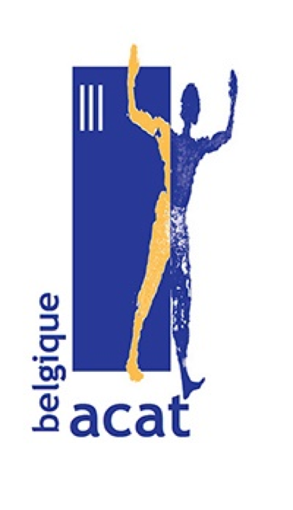**MANIFESTATION of ACAT-Belgium**

**to demand the release of**

**Raman PRATASSEVICH, Sofia SAPEGA, as well as that of**

**ALL POLITICAL PRISONERS DETAINED IN BELARUS!**

***Where?***

***In front of the Belarusian embassy***

***(at the corner of rue Edmond Picard and avenue Molière, in Ixelles)***

***When?***

***Saturday 29 May 2021, from 3pm to 4pm***

**Since the summer of 2020**, the people of Belarus have been been calling for free elections and the establishment of the rule of law in the country, through staging massive and peaceful demonstrations. In response, the country's authorities have unfurled an **escalation of repression**, not shying away from systematic violence, such as beatings of demonstrators by law enforcement officials, mass and arbitrary arrests, frequent use of torture, unfair trials, and heavy sentences of prison terms for opponents, including minors. Belarus is also the last European country to apply the death penalty!

**On Sunday 23 May 2021**, a further step in the repression of opponents was taken, when the Belarusian authorities hijacked a European plane to Minsk in order to allow the Belarusian authorities to arrest **Raman Pratassevich**, an opposition journalist, and his companion, **Sofia Sapega**, who were travelling on the plane. The fate of both prisoners is all the more worrying as the Belarusian authorities accuse Raman Pratassevich of terrorism and Belarus continues to apply the death penalty. There is every reason to believe that Raman Pratassevich and Sofia Sapega, like other political prisoners in Belarus, are being tortured to make them confess to imaginary crimes.

ACAT, whose raison d'être is to protest against torture and cruel, inhuman and degrading treatment and punishment, and to support human dignity, including in detention, calls for a demonstration in Brussels, in front of the Belarusian embassy, in support of Raman Pratassevich, Sofia Sapega, and all other political prisoners detained in Belarus, on Saturday 29 May 2021 from 3 to 4 pm.

For more information: www.acat.be

*N.B. Sanitary measures against Covid will be met during the whole event.*